A Sample Rubric for the Improvisation Workshops
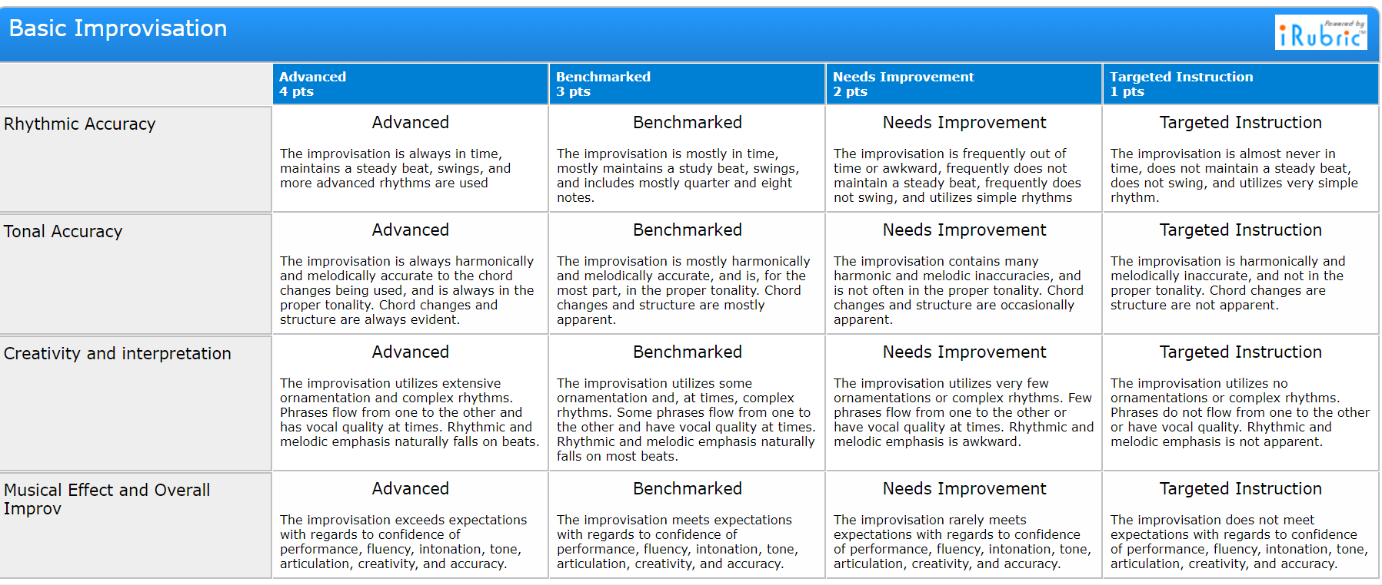
https://www.rcampus.com/rubricshowc.cfm?sp=yes&code=LX65776&
If you go to the hyperlink, you can customize your rubric for submission to PDE and PMEA.

